The source code for problem 4 can be found in the file Traversals.py.

For this graph the output of connected_components(graph) is:

1. 0 3 4 2 5 1

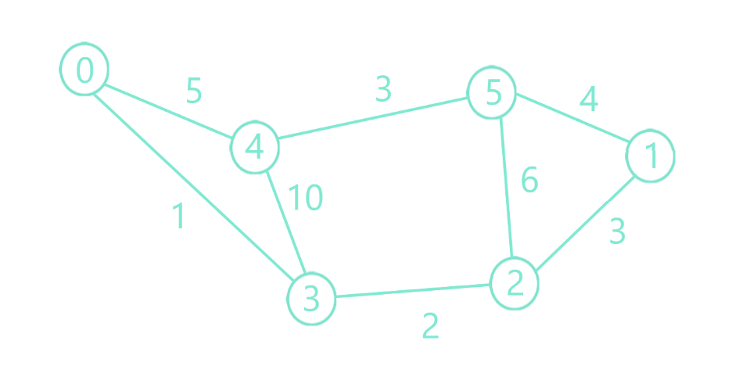

For this graph the output of connected_components(graph) is:

1. 0

2. 1 2 3 4

3. 5 6 7 8 